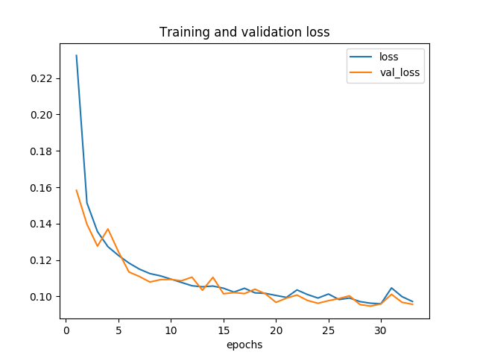Figura 1: CNNBase_v2 SSIMLoss
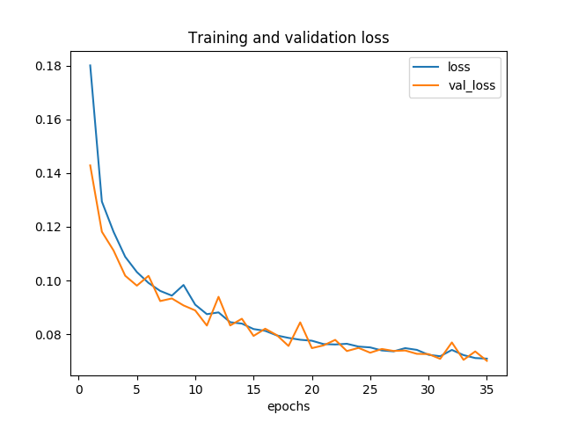Figura 2: CNNBase_v1 SSIMLoss
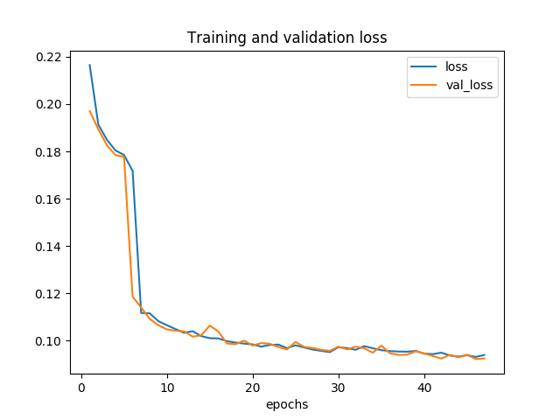Figura 4: Skipconnections_v1 SSIMLoss
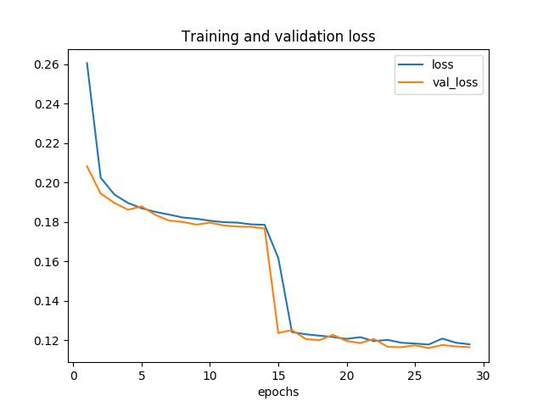Figura 3: Skipconnections_v2 SSIMLoss
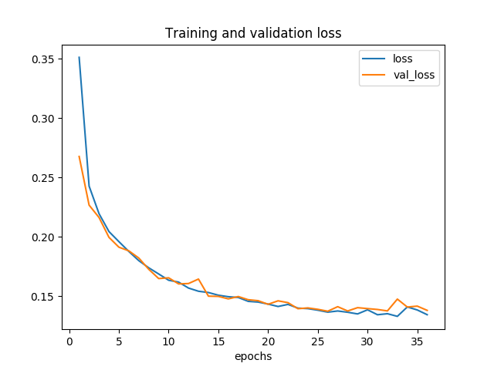Figura 6: ResNet_v1 SSIMLoss
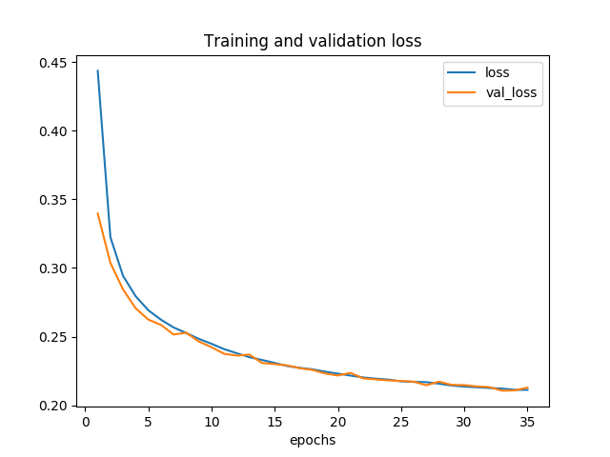Figura 5: ResNet_v2 SSIMLoss

